



**Bachelor of Computer & Information Sciences Research & Development Project**

Reflective Report

**Newsletter project**

Supervisor: MR. TRAN MINH TUAN

Client: QUACH HONG ANH KHOA, QUACH VAN HUNG

Student Name: Nguyen Thai Huy Student ID: 1284696

Role: Leader, Developer, Business Analysis, Project Manager

# ABSTRACT

# **Section 1 – Introduction** About the project, identifying objectives, content and scope of implementation of the R&D projects.

# **Section 2 – Project Evaluation** Evaluation of the project achievements against those outlined in the project proposal.

# **Section 3 – Theory and Practice** Analysis of the project with regard to relevant theory (frameworks, models, processes), including critical evaluation of the application of those theories to the project

# **Section 4 – Personal and professional development** Evaluation of the team roles, the effectiveness of the team members, and my interaction with team members if the project was a group project

# ACKNOWLEDGMENTS

My first thank I want to give to AUT University, ITEC HCMUS for give me a lot of knowledge not only about IT, many thing about business and equip for me all skill I need for my work and all my courses. Best thank in project I want to give my particularly grateful for Mr.Tuan, my supervisor who help us in all time we implement the project. Mr Huy, technical supporter, who was teaching us about technical skill about C# throughout the project development period.

My second thank I want to give for NIFTIT to accept our team and believe in my knowledge when they give us their project without complain. Best thank in NIFTIT I want to give for Khoa (CEO of NIFTIT) and Hung (Business developer), two key stakeholders of our project represent for client. Khoa gave us many new technologies, tools like Sharepoint, Sitefinity, Sitecore… work with Khoa we have opportunity to accept new system that we never seen before. Hung was an important person who connect between us and Khoa, he is a flexible person, lucky for us to working with them.

My last thank is to all staffs in ITEC that support for us in that project Mrs Hanh, Mrs Duy, Mrs Nhi and my coordinator Mr Petteri, Mr Leo, Mr Vu.

Thank to my two friends who walk with me side by side in the project way. They help me improve my soft skill in many role.

Table of Contents

ABSTRACT 1

ACKNOWLEDGMENTS 2

1. INTRODUCTION 4
2. PROJECT EVALUATION 5
   1. Plan 5
   2. Achievements 5

Experienced with Code igniter 5

Linux as simple 5

Relationship with supervisor 6

Writing documents 6

Keep a log 6

* 1. Negligence 6

Demurrage 6

Not well designed 6

Manpower shortage 7

1. THEORY AND PRACTICE 8
   1. SCRUM methodology 8

Theory 8

Practice 8

* 1. Codeigniter HMVC 9

Theory 9

Practice 9

1. PERSONAL AND PROFESSIONAL DEVELOPMENT 10
   1. Investigation 10
   2. Further Research 10
   3. Work with plan 11
   4. Group Working 11
   5. Just Skip 11
2. CONCLUSION 12

References 12

APPENDIX A: MY CONTRIBUTION 13

APPENDIX B 18

1. INTRODUCTION

## Overall

I’m **Nguyễn Thái Huy – Automation Team** play as roles: team leader, project manager, developer, business analysis.

**Strength:**

* My strength before receiving the project:
* Good communicated ability.
* Experienced in managing project team
* Communicate beautifully in English.
* Ability to absorb well and adapt well to new technologies at the first approach.
* Calm down in every situation and ability to resolve good contradictions.

**Weaknesses:**

* Having quickly forgetfulness
* Having less knowledge of Business Analysis and Project Management Method.
* Strong technical skills.

The Automation project is a website that create from the idea of Khoa (our client). That website had made base on the available RFP’s answer system of company.

This project is a website which developed on Asp.net – C#. This website allow customers to create and upload a request for proposal, and many agencies-companies can review and answer these request for proposals. When agencies-companies submit the solution, the website will generate a proposal. Next, customers can observe proposals which answer for their requests, and they can decide that proposals suitable for them.

**The benefits of the website:**

* Customers easily create and manage RFPs.
* Customers do not need to send many RFPs to many different companies via email and must search for the company they need on the search engines.
* It will be less time consuming and more convenient for the RFP to acquire the necessary information to create a suitable proposal.
* Managing the proposal is easier without having to check your mail regularly.

## Plan

When we started to receive the project from the client, all the team members met to discuss what to do in the project to achieve the best results. After discussing aspects of the project, the plan was agreed and set out as follows.

Aspect of the project:

Complete the project before the deadline of 1-2 months to correct the issues that arise when submitting the project.

Prepare the materials needed to study the solution for the project.

Preparation tools for project management (software, schedule).

Prepare the risks that may occur when doing the project and provide basic treatment in advance.

Analyze problems that the project may encounter and address possible problems in the project.

Brings the functionality of the customer's current system to the functionality of the website and improves the convenience of use.

The aspect of communication with the client:

Keep in touch with the client and try not to lose contact with the client.

Learn communication tools that customers master or use to make it easy for customers to confirm project-related documents.

Try to keep the customer happy when communicating. Note again full information requirements of the customer to serve the planning of the project.

Group aspect:

Maintain direct communication between team members, continually discuss project issues.

Learn how to manage groups of preceding groups. Address all problems that may arise about the team members and find out how to fix them first.

Capture the strengths of the team members to work properly.

Bring out the weaknesses of members who need improvement or learning more to support the development of the project.

The interface with the supervisor:

Unified meeting date with supervisor.

Select unknown information about the project to discuss with supervisor for advice from supervisor.

Ask supervisor for new or needed tools and libraries for the development of the project.

1. PROJECT EVALUATION

## Achievements

### Experienced with Business Analysis Role

This is my first time doing a real company project as a Business Analysis (BA). To take on this role, I learned a lot about BA-related materials before entering the customer acquisition phase.

The main task of a BA is to communicate with the client, taking on the role of a bridge between the team and the client. The main skills I gained when becoming a BA were:

* Analyze customer requirements very carefully.
* The way of communication makes the client happy after each meeting.
* Clear presentation for both the team and the client so that both of them get the information BA wants to convey.
* How to draw Business Process, System Architecture, Workflow. Detailed explanations of the diagrams drawn for all stakeholder projects.
* Knowing the rules after implementing any segment must also include a customer confirm document, this document as well as a proof to give when the client has any unwanted complaints to the project. , Or want to make groups difficult for some subtle reasons.

### Experienced with Leader Role

This is the fourth time that I have accepted a project as a leader, so I have already equipped myself with some knowledge of group management before implementing this project. Although I have knowledge of project management but this is also the first time I receive a real project from a real company outside so the pressure on all aspects of the project is also a lot. As expected, after the project, I learned a lot about group management as a leader:

Understand the strengths and weaknesses of the members and assign specific work.

Calm down to solving the problems from baby to child arising in the group during the project development process.

Know the business measures to resolve conflicts among team members.

Know how to motivate team members and gently push the work of the members without making people angry.

Know the conflicting constraints among team members to the lowest level.

### Experienced with Developer Role

This is the role that I am least confident in the project because my technical skill is the weakest thing. However, it is also one of the roles that I learned the most from it.

C # language is not my strong point in technical skill so I have read a lot of C # documentation and C # libraries that can be applied to the project before the development of the project. Thanks to that, I have acquired a lot of new libraries and new frameworks suitable for different project types.

In this role I have to thank Mr. Huy a lot, who taught me all about the code in the process of starting a website for the project. A lot of mistakes I have never met have been solved but it took me a while but it gave me great motivation and joy to overcome the work myself.

### Project Manager Role

This is a role that I consider to be the most complex and heavy role in project implementation. This is my first time as a project manager, so my knowledge and experience on the project manager is very limited.

In this section I have to remember a lot of my supervisor in advising on choosing the right project management method and how to direct the project team to follow that method. Each method has its own advantages and disadvantages so choosing the right method to apply is extremely difficult. We had to change a lot of project management methods from SCRUM to PROTOTYPE and finally to PROTOTYPE and WATERFALL.

After experiencing the role of a PM I got to know a lot of things like:

Understand the basics of methods like SCRUM, WATERFALL, PROTOTYPE.

Flexible development methods can be applied flexibly and in any project.

Can use many tools to manage projects like SCRUMDo, Trello.

## The important of the project to the organization

### Short term significant

This project is designed to save maximum time and human resources in approving the RFP and exporting the proposal to the client. It is because time and human resources are reduced will lead to much reduction of costs involved and increase the number of customers. Instead of working with the company via email, customers have to check mail continuously, this time through the protocol interact with the website will give customers the convenience when the company actively search and send the proposal to customers.

### Long term significant

It is because of the convenience of the communication method when passing the project, the number of clients will increase over time and the number of partners working with the company will increase significantly. The company will save money by reducing the time and manpower, and will benefit from successful contracts from partner companies.

1. THEORY AND PRACTICE

## Methodology

*1.1 SCRUM:*

***Theory***

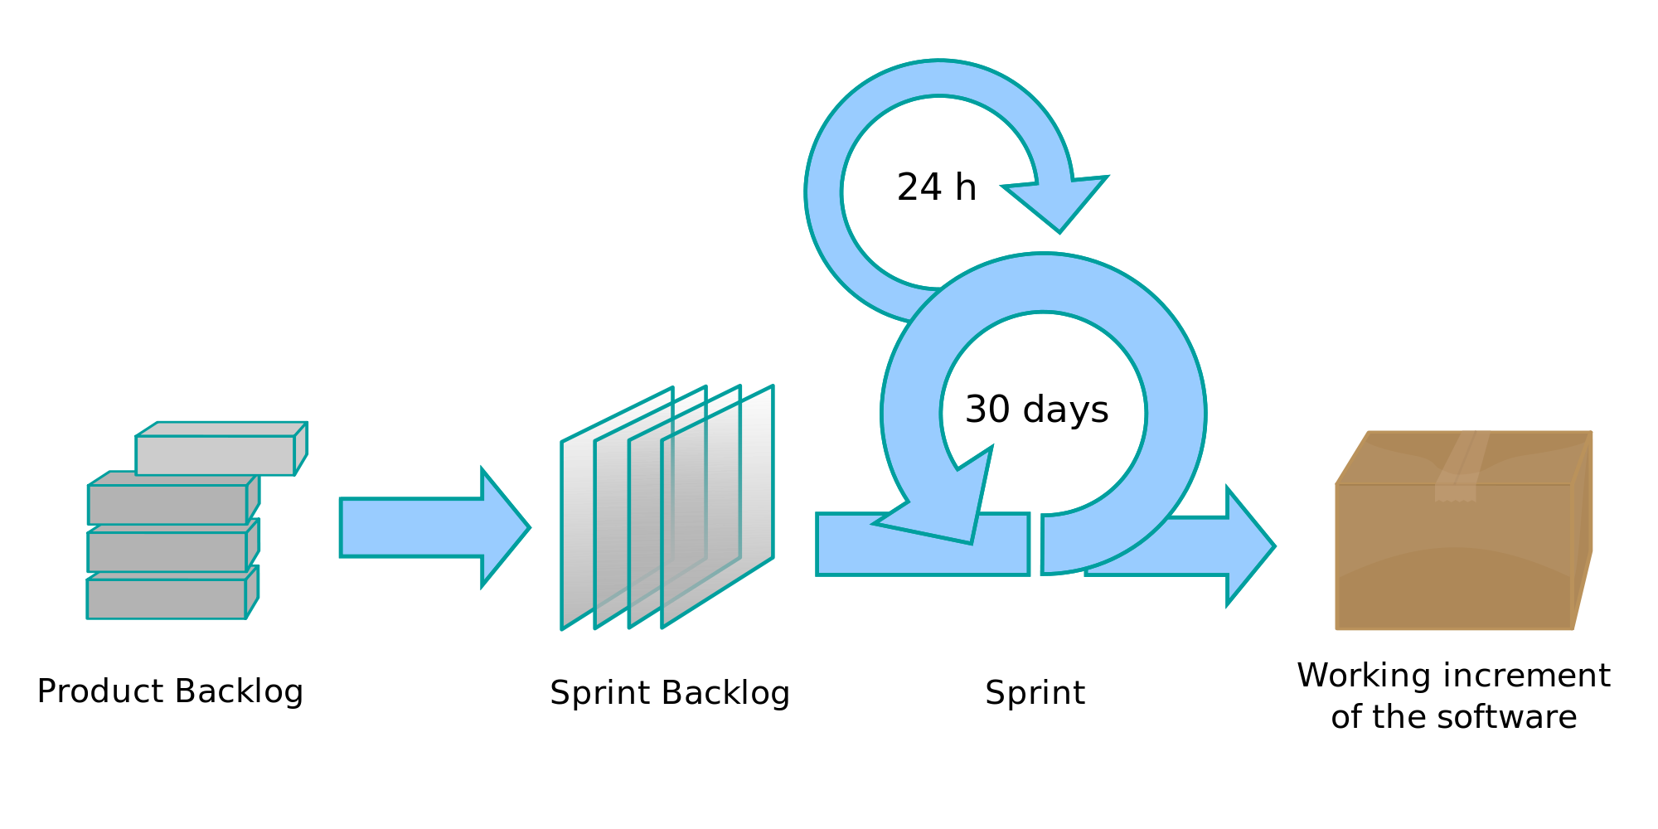

***Practice***

At the beginning of the project, our team used the project development method SCRUM for several reasons:

* As an entirely new framework for project development is much improved from the previous method.
* Our project is still in the process of finalizing, so the constant changes in customer requirements are inevitable but with SCRUM we have opportunity to meeting customer regularly and reduce the change of customer requirement.
* SCRUM works well for the number of members of the group from 3-8 people.
* Team does not have team leader and is a self-managed groups. Everyone in the group has the ability to make decisions and everyone can change for different roles.

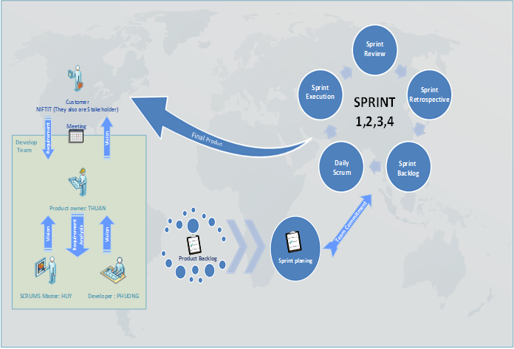

*WATERFALL:*

***Theory***

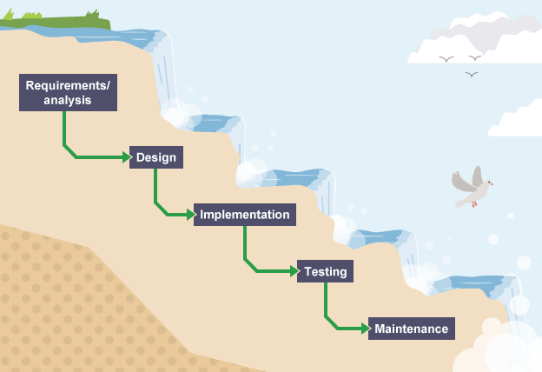

***Practice***

After the project started in the operating phase we had to change the project development method to another method for a number of reasons:

* Team members have a different level and knowledge. It is not suitable for SCRUM which is all team need the same level to run the project.
* We can’t make a daily SCRUM meeting because each member have a different time for working and location
* Daily meetings sometimes frustrate team members
* The client also busy and hard to make an appointment frequently.
* SCRUM method is really hard to use and take a lot of time for learning how to use it
* This methodology needs experienced team members only. If the team consists of people who are novices, the project cannot be completed in time.

*WATERFALL:*

***Theory***

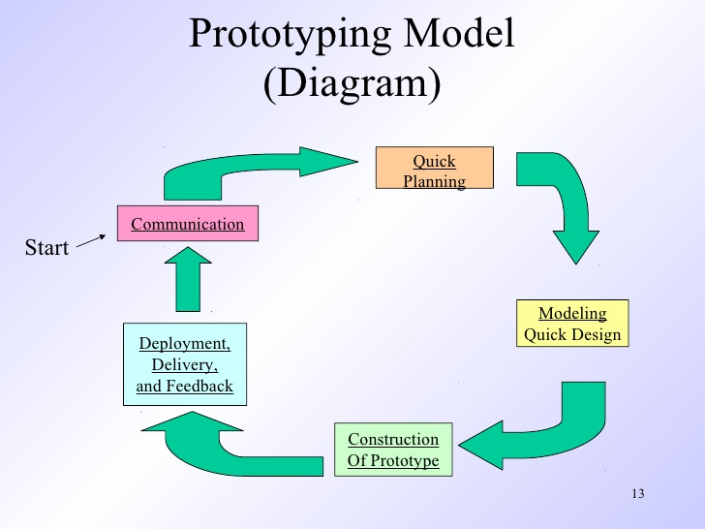

***Practice***

When applying the waterfall to the project, there is a problem that the requirement is not clear, so our team is compelled to find a solution to clear the requirement before applying the waterfall to develop the project. After discussing other possible methods, we chose the prototype method. But when applying the prototype to the project, we discovered a problem, that is the prototype method represents the layout outside the site, can not present the inside of the site for the client to see the prototype method. So the team decided to combine the prototype method with the diagrams such as business process, system architech, use case to show the project aspects to the client and it took me a long time to find. Understand how to display those diagrams.

## Approach

## *Sharepoint*

***Theory***

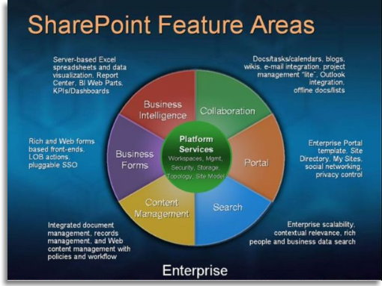

***Practice***

Sharepoint is the first approach I choose for this project with a number of advantages:

* Word, excel integration for users to create and edit documents right on the web
* Agencies and customers can discuss, schedule and communicate with each other right on the web via Sharepoint outlook.
* NIFTIT RFP web functions such as sorting, searching, authoring, creating pdf files based on documents created on the web are included.
* All documents created after creation will be stored on Onedrive, the programmer does not need to create a separate server for it because it is built into sharepoint, including both the images and personal information.
* The security of sharepoint is very good.

The biggest advantage that made us choose sharepoint the first time was because our current professional client is Sharepoint. If we use sharepoint as a project approach, we will learn a lot of new knowledge about software we do not know.

But after discussing with the client about using sharepoint for the project, we encountered a big problem. The client has suggested some reasons why we can not apply sharepoint to the project:

* Sharepoint is an internal platform.
* Large scope.

Then we realized that Sharepoint could not be applied to the project so we chose another method for the project.

The next method we chose was Sitefinity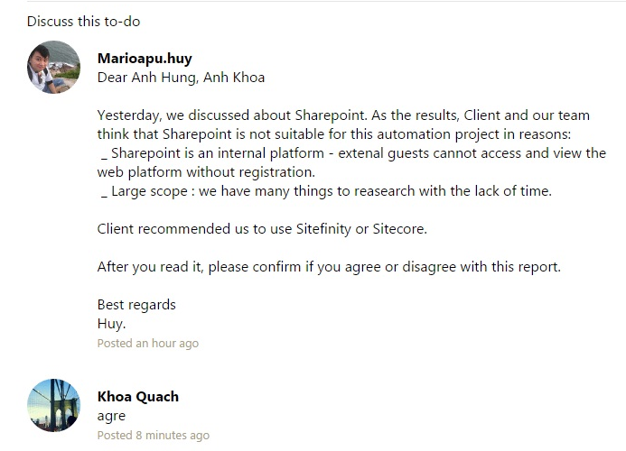

## *Sitefinity*

***Theory***

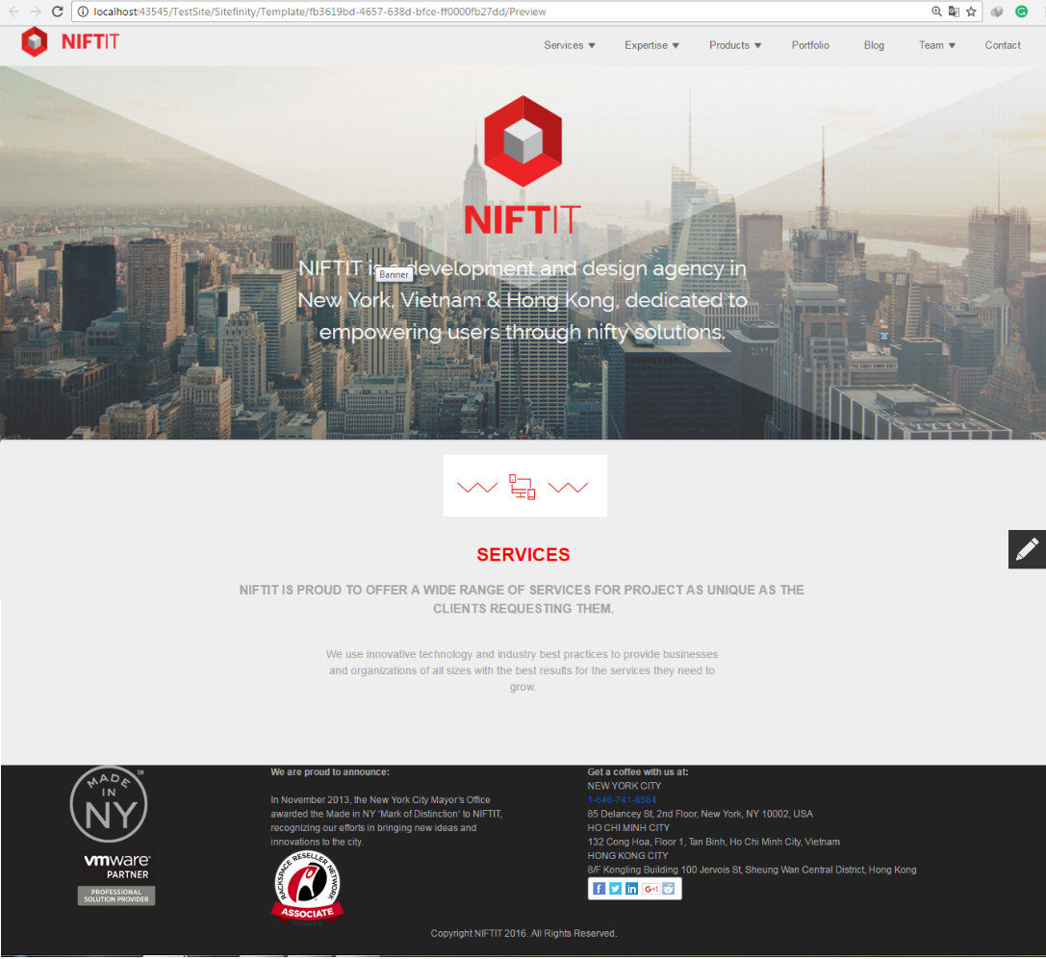

We decided to choose Sitefinity for this project for a number of reasons:

* Available functions such as permissions, sign-up, search, and other important modules of the site are available.
* Flexibility in designing web pages on the browser and editing css files on the browser without support software (Dreamweaver, Visual Studio).
* Connect directly to the database and generate tables available to users who simply delete the information right on the web, the database will automatically save data directly.

***Practice***

I and Thuan have been given the opportunity to train themselves on Sitefinity at the company office for several days to understand how Sharepoint works. Since this is a new web design tool and the company has no human resources and knowledge of Sharepoint, so many bugs are generated and we have to deal with a lot of time manually.

After using Sitefinity we discovered two inadequacies:

Site finity can only be used on one machine when another machine logs in. The error will appear and other members can not edit the site.

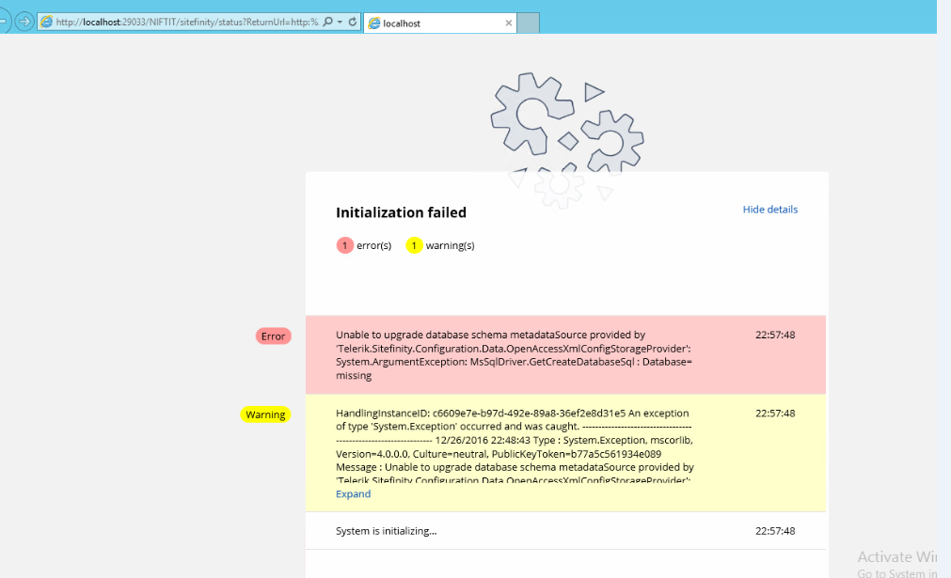

Time for the trial is too short (1 month) and can not extend the trial period unless a high fee is required.

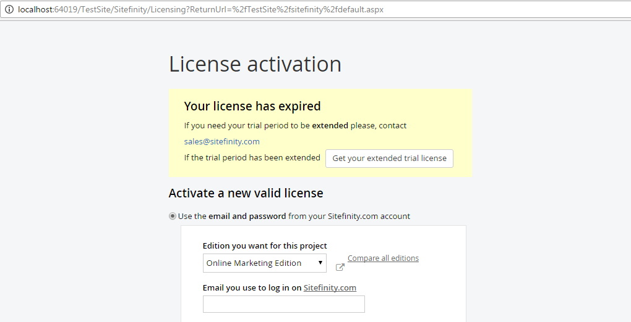

1. PERSONAL AND PROFESSIONAL DEVELOPMENT
   1. **Soft Skill**
   2. Communication Skill

This is my most improved skill in the project, although it was my strength before the start of the project but I still have a lot of flaws in communicating my ideas to the members of the team and follow. Improvements in my communication skills are as follows

Communicate with customers:

* Gentle and polite, using the language at the beginning and the end
* Understand the customer's intentions that develop ideas, not the ego in the saying

Communicate with groups:

* + Do not heat up, calm resolve the conflict within the group when there.
  + Put yourself in the position of the team members before discussing them with a problem

1.2 Management Skill

Teamwork:

* Know how to listen to members' opinions, analyze and lightly respond and explain to people if there is a mistake.
* Let members freely and openly develop their ideas for the project
* Create credibility for the members, when the division, the members are willing to take up their position does not complain.
* Improve decision-making assertiveness for a problem because before making a decisive decision, people have discussed each other thoroughly.
* Dare to take responsibility for the shortcomings of the team as a teamleader.

Planning:

Previously doing anything from small to large I did not plan anything, even if the plan was very sketchy and when done is very sloppy. After implementing this project I learned the careful planning before everything for example:

* Arrange agenda before every customer meeting, supervisor meeting, group meeting.
* Schedules and schedules each member for each project week and deadline.
* List the materials that should be investigated as soon as a new solution is available.

Time management

In this part, I was introduced to a new tool, Toggl, which was introduced by Huy as my supporter code for the team. Since I knew Toggl I used it to track time whenever I was working on a project to know how much time I spent on a project.

I also use Microsoft Project to schedule myself at the end of each day. If there is a task beyond the time I set, I will reduce the time specified by the next task down and continue the other tasks.

Documentation:

A lot of documents were generated when I started the project, so I could get a handle on what the project needed and what the documents contained. Thanks to that, I have the template needed for my own documents to carry out the next project.

One more thing that I have when making these documents is that my English has improved a lot. Through the implementation of materials such as the proposal I have also improved the analytical capabilities and the way of expressing ideas in the document.

Presentation:

This is a skill I am quite confident because this skill I have been practiced quite a lot through the lectures group so far of the school. However, in this project I also learned how to respond quickly to the questions you have given and how to handle difficult questions as well as how to arrange the presentation location for the members in the group on the level of each person.

* 1. **Hard Skill**

2.1 Project management

In this project we have a total of 3 members and each of us has different backgrounds in different areas of the project so it is very difficult for each person to know each other. The biggest thing I learned in this section is how to analyze each person's skills, understand the true weakness of each person in the project to assign the right work.

Navigating and maintaining a team to the right team is a difficult task for a project manager. I admit I am quite weak in this part but I have learned a lot from it.

* I have learned how to choose a project development method suitable for a growing project
* More flexibility in changing the way the project is developed when problems arise in relation to the mode of development.
* Prescribing the way to divide the roles of members equally with roles in moderate project development methods that are consistent with the knowledge and skills inherent in each team member.
* Plan and allocate time for tasks within the project that fit the development method.

The method of project development:

**SCRUM**: Understand the use of SCRUM for the project, the conditions to apply SCRUM, the software required to manage SCRUM (SCRUMdo, Trello, Agilo for SCRUM ...), meetings need in SCRUM (Sprint Planning Meeting, Daily Sprint, Sprint Retrospective, Sprint Retrospective, a minimum and maximum of two (2-4 weeks) SPRINT, SPRINT has a total of how many meetings, the final product of each SPRINT, grasp the role of Project team in SCRUM and the main job of those roles.

**WATERFALL**: Understanding the advantages of waterfall is easy to use and easy to apply to the project. The biggest downside of waterfall is the need to clear the requirements so the risk of project implementation is high.

**PROTOTYPE**: Learn how to draw prototype using Balsamiq program to design website layout as well as forms on website.

2.2 Business Analyze

For the first time as a business analyst, I learned how to apply the knowledge learned in getting a client request, from the knowledge I had listed what was required and what I learned. Need to ask to clarify those requirements. After receiving the request, I analyzed it and drew up diagrams to reproduce the components of the product based on those requirements.

All of the requirements that have been analyzed have been outlined by Visio 2016. The documents I drew with Visio are:

* + - * Workflow.
      * Use Case.
      * Business Process.
      * System Architechture.

The process of drawing System Architechture Model is the most time consuming part of my process during my BA. So far I have never painted SAM, so it is very difficult to read the concept of SAM because there are so many specialized words that I have to spend a lot of time researching the meaning of SAM. Me and Thuan took two weeks in a row to be able to draw a local SAM of the site before the site began to be created. Previously, this job was assigned to Phuong for 3 weeks but Phuong did not understand SAM and did not finish the job so Thuan and me took up this job because of limited research time.

2.3 Development

The tools and software I used in this project:

* + - Sharepoint.
    - Sitefinity.
    - Sitecore
    - iTextSharp C#.
    - Trello.
    - Basecamp.
    - Basamiq.
    - Toggl.
    - Microsoft Visio
    - ASP .Net
    - Microsoft SQL Server.

This is the first time I use C # and Microsoft SQL Server for a real project of a company outside of school. I learned a lot of things while coding the web, lots of bugs were generated during code and I had to spend a lot of time fixing it.

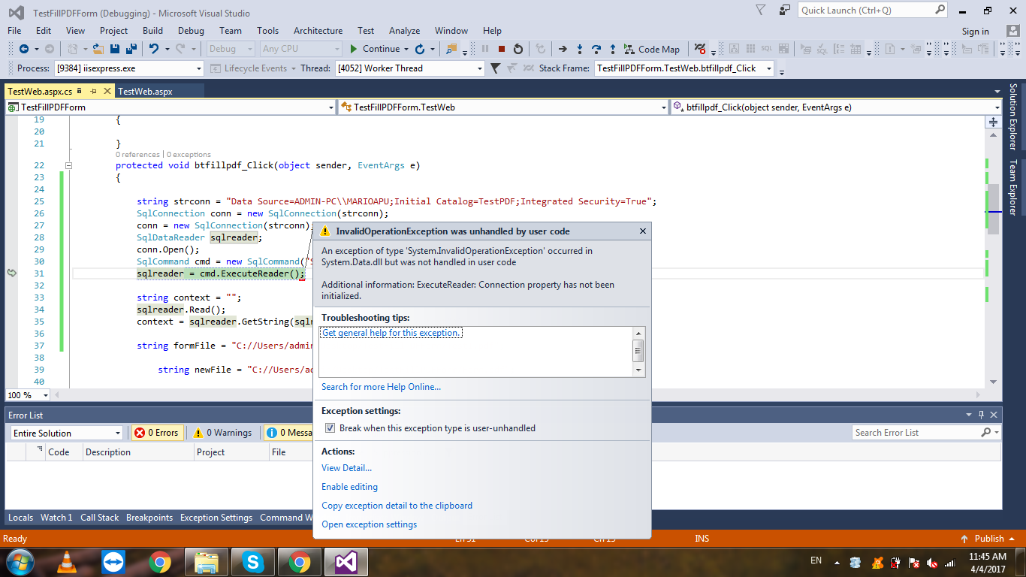

Impression when development:

During the development project phase, I was assigned a key module in the project that was to fill the information into the pdf file. This is an important function that the client mentions first when it comes to requirement and is a difficult module for me because I have not seen this module ever. Therefore, the implementation of this module put a lot of pressure on me. Within 2 days I searched on all google and youtube pages but could not find the results I needed. On the third day I came to the assistance of Mr.Tuan's supervisor but the results were not what I expected, Tuan advised me to redesign the entire Proposal template of the customer to issue a .html file and then execute Fill the code into the domain set there and it is impossible because the structure in the proposal template is very complex and takes a lot of time to implement while I have very little time to complete..

After a deadlock I went to the teacher Mr.Huy as the technical supporter of the group for help, he told me to redesign the entire proposal template with C # code to print the pdf file and then assign the blank area and fill information later.

Listen to the teacher I made the module in the direction of the teacher. First I made the output of a pdf paragraph. After my grandfather made a pdf export to a table and exported it to a table of contents. The big problem is when I can not edit that table and table of contents. Not frustrated, I started looking for a new solution for myself. At that time, I found a pdf file with an interactive form field.

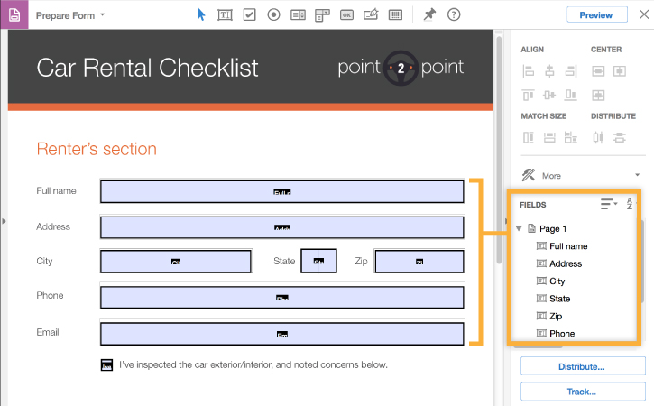

These are form fields that interact directly with C # code through Visual Studio. I have tried and successfully filled the information in the pdf. The results I received made me very happy, I completed this module earlier than my own deadline of two days and I learned something completely new that I had not been exposed before.

* 1. **Identification Of Future Learning Need**

Even though I have received a lot of knowledge after implementing this project, I think I still need to add a lot of knowledge and fix a lot of my own for the following projects:

* Complete requirements analysis and draw business models based on those requirements.
* Rule the law with team members when working in teams. Do not let any of the members of the team neglect the work that affects the work of the group.
* I have to learn a lot more about programming ASP .Net and about MS SQL Server.
* Plan more carefully for everything from the start of the project.

1. THE EFFECTIVE OF TEAM MEMBERS

Our team has a total of 3 members:

* Thuan (Developer, Business Analysis Assistant, Leader in Dervelopment).
* Phuong (Quality Assurance, Developer)
* Me (Team Leader, Business Analysis, Project Manager, Development Assistant, Developer).

The three members of our team take turns taking on roles in the project and helping each other when problems arise.

**Thuận:**

Being an extremely active member in the group, having great knowledge of website development and app, the strength of the pros is front-end. As a quick job solver and a very good grasp, most of the tasks are completed before the deadline and there is no need to revise or fix anything. Thuan is my best collaborator in this project, it has helped me a lot from the BA to the final. Due to their geographical location, they are very convenient for meeting and implementing the project. Thanks to Thuan, my development ability has improved as I took on the role of development assistant, a facilitator in the process of implementing my modules. Many errors generated while I make my module are resolved. I am very grateful to Thuan in this project and look forward to working with in future projects.

**Phương:**

Take on the role of Tester and write all of the group's meeting minutes. My own sense of self in the direction of, Phuong do the job is quite slow and very passive in the process of project. Almost all the plans to do the work are set by the other two members and not completely take the job. Thinking and logic of a problem is very weak. Phuong ‘s working are almost done or have to fix a lot. Simple tasks such as making a power point file or synthesizing the proposed information into a single copy when given to the media, it takes a lot of time to make and submit your post next day report. Therefore, the members of the group can not review the article to correct the quality of the report is very poor. As a team leader, the way to be a member made me the most disappointed. I hope that there will be improvements in upcoming projects.

**Me:**

I was too sketchy to organize the project, not assigning a specific record and confirm from the team members, but only through the trello and remind people on skype. Many extended contradictions of group members that I have not resolved yet. I feel after this project that I need to improve all my soft and hard skills so much that I can carry out the next project in the future perfectly.

1. CONCLUSION

This project has given me a lot to learn, to absorb and gradually improve myself. In the 8 months of project implementation, I had to undergo many challenges from the side. Since the capture of R & D I have failed interviews with 3 companies and NIFTIT is the last company that accepts me to carry out projects for them. I am very grateful to NIFTIT for facilitating the implementation and completion of this project.

What I fear before accepting these projects is that my knowledge is very limited. All I have is a series of theories learned in the lecture hall and it is difficult for me to apply it in practice. The difficulties and challenges that constantly come to me from team building, scheduling, time management, group management, learning new technologies, applying the project development methods that I have learned from the subject Project Management of Mr Vu for this project. Thanks to these challenges, I feel that I have grown up a lot. I felt confident when dealing with customers, when taking customer requests, when the customer interviewed, when demo products for customers. I feel this project will be a big step for me so I can become a project manager later.

# References

<https://www.scrum.org/>

<https://www.asp.net/mvc/overview/getting-started/introduction/getting-started>

<https://www.asp.net/mvc/overview/getting-started/introduction/getting-started>

<https://www.tutorialspoint.com/sharepoint/index.htm>

<https://www.khanacademy.org/computing/computer-programming>

http://www.sitefinity.com/

<https://www.youtube.com/watch?v=zFenJJtAEzE&list=PLhQjrBD2T383Xfn0zECHrOTpfOSlptPAB>

# APPENDIX:MEMBERS CONTRIBUTION

# **Contribution of proposal**

|  |  |  |  |
| --- | --- | --- | --- |
| **Task** | **Phuong** | **Thuan** | **Huy** |
| **Proposal version 1.0** |  |  |  |
| 1. Skills and knowledge involved | 60% | 20% | 20% |
| 3. Existing system | 20% | 20% | 60% |
| 4. Problem and Solution | 20% | 20% | 60% |
| 5. The workflow | 20% | 20% | 60% |
| 6. The RFP web platform structure | 10% | 20% | 70% |
| 7. The User activity in RFP web platform | 10% | 20% | 70% |
| 8. The Agency activity in RFP web platform | 10% | 20% | 70% |
| 9. Objective | 60% | 30% | 10% |
| 10. Scope | 60% | 30% | 10% |
| 11. Approach | 30% | 40% | 30% |
| 12. Methodology | 30% | 30% | 40% |
| 13. Deliveriable | 20% | 20% | 60% |
| 14. Cost Incurred | 20% | 20% | 60% |
| 15. Risk | 10% | 80% | 10% |
| 16. Product backlog | 0% | 60% | 40% |
| 17. Develop Plan and Timeline | 20% | 60% | 20% |
| Proposal.pptx | 80% | 10% | 10% |
| **Proposal version 2.0** |  |  |  |
| 1. Edit Existing System | 20% | 40% | 40% |
| 2. Edit Problem Solution | 30% | 30% | 40% |
| 3. Edit Methodology | 20% | 20% | 60% |
| 4. Edit Cost incurred | 20% | 20% | 60% |
| 5. Edit Product backlog | 10% | 70% | 20% |
| 6. Plan and Timeline | 0% | 50% | 50% |
| **Proposal version 3.0** |  |  |  |
| 1. Edit Methodology | 60% | 20% | 20% |
| 2. Edit Schedule and Plan | 20% | 40% | 40% |
| MidTerm Review.pptx | 20% | 30% | 50% |
| **Business Process Model** | 10% | 30% | 60% |
| **Prototype** | 30% | 30% | 40% |
| **System Architechture** | 0% | 50% | 50% |
| **Use Case** | 0% | 30% | 70% |

|  |  |  |
| --- | --- | --- |
| **Phuong** | **Huy** | **Thuan** |
| 24% | 43.3% | 32.67% |

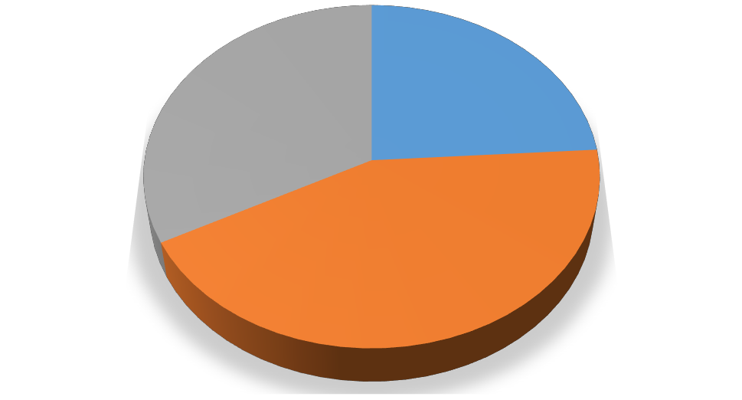

Phuong

Huy Thuan

**33%**

**24%**

**43%**

# **Contribution of development**

|  |  |  |  |
| --- | --- | --- | --- |
| **Module** | **Thuan** | **Phuong** | **Huy** |
| **1. Template** |  |  |  |
| 1.1 Default Page | 50% | 0% | 50% |
| 1.2 Log in, Register | 50% | 0% | 50% |
| 1.3 Customer Detail Page | 50% | 0% | 50% |
| 1.4 Create RFP Page | 50% | 0% | 50% |
| 1.5 Create Proposal Page | 50% | 0% | 50% |
| 1.6 List of RFP Page | 50% | 0% | 50% |
| 1.7 Manage RFP's Answer (Customer) | 50% | 0% | 50% |
| 1.8 Detail of RFP | 50% | 0% | 50% |
| 1.9 Manage Proposal (Agency) | 50% | 0% | 50% |
| **2. Code Function** |  |  |  |
| 2.1 Log in, Register |  |  |  |
| 2.1.1 Button Login | 80% | 0% | 20% |
| 2.1.2 Button Register | 80% | 0% | 20% |
| 2.1.3 Authentication | 80% | 0% | 20% |
| 2.2 Customer Detail Page |  |  |  |
| 2.2.1 History form | 70% | 0% | 30% |
| 2.2.2 User Information form | 70% | 0% | 30% |
| 2.2.3 Manage RFP form | 30% | 0% | 70% |
| 2.2.4 Manage RFP's Answer Hyperlink | 30% | 0% | 70% |
| 2.2.5 Manage Proposal are accepted | 70% | 0% | 30% |
| 2.3 Create RFP Page |  |  |  |
| 2.3.1 Submit button | 70% | 0% | 30% |
| 2.3.2 Upload file function | 80% | 0% | 20% |
| 2.4 Create Proposal Page |  |  |  |
| 2.4.1 Next button | 70% | 0% | 30% |
| 2.4.2 Back button | 70% | 0% | 30% |
| 2.4.3 Finish button | 50% | 0% | 50% |
| 2.4.4 Fill information to PDF function. | 30% | 0% | 70% |
| 2.5 List of RFP Page |  |  |  |
| 2.5.1 Show RFP form | 70% | 0% | 30% |
| 2.5.2 Link to Detail of RFP page | 70% | 0% | 30% |
| 2.5.3 Search function | 0% | 100% | 0% |
| 2.6 Detail of RFP |  |  |  |
| 2.6.1 Answer button | 70% | 0% | 30% |
| 2.6.2 Download button | 30% | 0% | 70% |
| 2.6.3 Comment box | 0% | 100% | 0% |
| 2.7 Manage RFP's Answer(Customer) |  |  |  |
| 2.7.1 Show list of RFP's Answer | 30% | 0% | 70% |
| 2.7.2 Download function | 30% | 0% | 70% |
| 2.7.3 Submit function | 30% | 0% | 70% |
| 2.8 Manage Proposal (Agency) |  |  |  |
| 2.8.1 Show list of Proposal for Agency | 30% | 0% | 70% |
| 2.8.2 Download function | 30% | 0% | 70% |
| 2.9 Notification |  |  |  |
| 2.9.1 Notification when customer accept | 40% | 0% | 60% |
| 2.9.2 Notification when new Proposal are created | 40% | 0% | 60% |
| **3. Database** | 40% | 30% | 30% |

|  |  |  |
| --- | --- | --- |
| **Thuan** | **Huy** | **Phuong** |
| 50% | 44% | 6% |

1. **My Workng Time**

# APPENDIX B

Assessment Criteria for Research & Development Project - **Reflective Report**

**Stdent:** Nam Hieu Nguyen - 14873736

This Report will be assessed with reference to the broad headings below.

|  |  |
| --- | --- |
| **CRITERIA** | **FEEDBACK** |
| Cover page (must have title, student name, ID No., date, supervisor’s name and paper number).  Abstract ½ page  Acknowledgments ½ page  Table of contents 1 page  Introduction 2 - 5 pages |  |
| Project evaluation (2-5 pages)   * Evaluation of the project achievements against those outlined in the original project proposal/learning agreement * Evaluation of the significance of the project to the organization (including both the development of the project in the short term and the long term significance) |  |
| Link between theory and practice (2-5 pages)   * Analysis of the project with regard to relevant theory (such as frameworks, models, processes), including critical evaluation ofthe application of those theories to the project * Critique of the research or development methodology adopted in the conduct of the project |  |

|  |  |
| --- | --- |
| Personal and professional development (2-5 pages)   * Evaluation of own personal and professional growth against the originally expected skills and knowledge to be acquired in the project proposal/learning agreement. * Identification of future learning needs.   Evaluation of the team roles, the effectiveness of the team members, and own interaction with team members if the project was a group project.   * For individual projects evaluation of the limitations of working alone, the |  |
| Summary and conclusion of total project experience (1- 3 pages) |  |
| References  Content should be linked to relevant literature and |  |
| Index of appendices  Appendix(ices) No formal limit on size or content |  |

#### Reflective Report Grade

|  |  |  |  |  |  |  |  |  |  |  |
| --- | --- | --- | --- | --- | --- | --- | --- | --- | --- | --- |
| **A+** | **A** | **A-** | **B+** | **B** | **B-** | **C+** | **C** | **C-** | **D**  Over 40% | **D**  Under 40% |

Signed by: ------------------------------------------- Date -------------------------------------------

(Project Supervisor)

Signed by: ------------------------------------------- Date -------------------------------------------

(Moderator)